Looking for a permanent, full-time job!
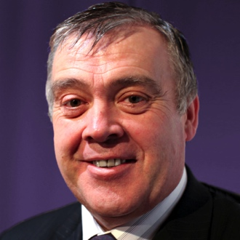
After nine years of working on my own as a freelance social media and digital marketing specialist I miss being part of a team that’s helping to drive the business forwards.
As you will see in my attached CV and LinkedIn recommendations documents, I have plenty of experience, I’m a well respected team leader, and I’ve a ready made social network of many tens of thousands of followers across all of the major social media platforms.
I’m looking for a full-time, permanent role as either a Corporate/Product/Technology Evangelist, or Head of Social Media and Communities.
Location isn’t a problem as I’m happy to relocate to anywhere in the world to take up the challenge.
In today’s social-connected world, your organisation can no longer settle for being “Good” at what it does, it needs to be seen as “Awesome” – And you also need someone like me who can help you create the hype, that builds trust, that makes everything go viral, yet has the knowledge and know-how to handle things carefully, and to minimise risks by training every member of your staff on how to react appropriately should anything ever go wrong.

Let me promote the public face of your organisation – by…
- creating “social buzz” about your products or services
- building vibrant online communities of clients and prospects
- re-purposing existing digital collateral into new digital revenue streams
- training your staff (and customers) to become brand ambassadors
- giving you complete insight to your online popularity, and implementing strategies to grow it
- implementing policies and procedures to keep your organisation safe online and minimise risks
- creating and delivering highly compelling presentations at conferences, seminars, and sales pitches
- writing articles extolling the value your products or services deliver to your clients
- publishing iTunes feeds of satisfied clients talking about their innovative use of your products or services
- making, publishing and distributing videos that help your clients get more from your products or services
- building professional looking, and highly ranked websites, blogs and micro-sites

I believe you’ll find that I’m the ideal person to help you to get your name and brand in front of the many thousands of people on the internet who are searching for exactly what you have to offer every minute of every day.

Don’t lose out – CALL ME NOW – Before I get snapped up!
+44 (0) 7979 593 970
ian@ianmckendrick.com

